
NEW YORK CITY COLLEGE OF TECHNOLOGY
THE CITY UNIVERSITY OF NEW YORK
300 JAY STREET, BROOKLYN, NY 11201-1909

Department of Computer Engineering Technology
CET 3510 - OL25 - Microcomputer Systems Technology lab

LABORATORY REPORT No_07

Lab_No_07 Integer Arthmetic Operations

Professor: Dr. Rubén Velásquez, Ph.D.
Spring 2021

Student’s Name: Ashahi Shafin
Student’s ID: 23607352

Preparation date: Due date:
April 07, 2021 April 14, 2021

- Table of content

- Table of content
- Objective
- Laboratory tools to perform the task
- Source code
Laboratory No_07 Example 7.1
- Source code Line Description
Laboratory No_07 Example 7.1
- Explaining the output results
Laboratory No_07 Example 7.1
- Program Flow Chart
- Table
- Comments
10.Conclusion

- OBJECTIVE

Laboratory No 7. Pratic arithmetic instructions for the 80x86, such as addition, subtraction, multiplication, division, and modulo. Write an lin line assembly language module in a C/C++ program by using general purpose registers. These are eight 32 bit registers that have the following names: EAX, EBX, ECX, EDX, ESI,EDI, EBP, and ESP.

- LABORATORY TOOLS TO PERFORM THE TASK
Computer NZXT
Microsoft visual studio 2015 Software
Microsoft Word 2019 Software
Microsoft Notepad Software

- SOURCE CODE

Laboratory No_07 Example 7.1

Source Code
#include <stdio.h>
#include <stdlib.h>
#include <iostream>
#include <time.h>
#include "windows.h"
using namespace std;

void addition(short int x, short int y);
void subtraction(short int x, short int y);
void un_addition(unsigned short int x, unsigned short int y);
void un_subtraction(unsigned short int x, unsigned short int y);

int main()
{
printf(" Lab_No_07_Integer_Arithmetic_Operations\n");
printf(" Module: C++ progrmming \n");
printf(" Ashahi Shafin, ID#23607352\n");
printf(" CET3510-OL25\n");
printf(" Presentation date: April 07, 2021\n");
printf(" Due date: April 14, 2021\n");
printf(" Example 7.1 arithmeticOperations.cpp\n");
printf(" file name: 7.1 arithmeticOperations.cpp\n");
printf("-----------------------------------------------------------------------------\n");

char ch, ch1, ch2, ch3;
signed short r1, r2;
unsigned short ur1, ur2;
cout << "Start your calculator Y/N, enter (Y) Yes or (N) No" << endl;
cin >> ch;
ch1 = ch;
while (ch1 == 'Y' || ch1 == 'y')
{
Menu:
cout << "Menu:\n";
cout << "1 = Signed Integer Arithmetic Operation (16-bit)\n";
cout << "2 = Unsigned Integer Arithmetic Operation (16-bit)\n";
cout << "3 = Exit\n";
cout << "Menu Options:\n";
std::cin >> ch;
ch2 = ch;

Submenu:
if (ch2 == '1')
{
cout << "Submenu - Input your choice\n";
cout << "a = Input two 16-bit signed number operands for addition and display\n"
<< " the sum in decimal and hexadecimal format, respectively.\n";

cout << "b = Input two 16-bit signed number operands for subtraction and display\n"
<< " the difference in decimal and hexadecimal format, respectively.\n";
cin >> ch;
ch3 = ch;
switch (ch3)
{
case'a':
{
cout << "Input two signed numbers operands in decimal format\n";
cin >> r1 >> r2;
addition(r1, r2);
cout << "======================================================\n";
break;
}
case'b':
{
cout << "Input two signed numbers operands in decimal format\n";
cin >> r1 >> r2;
subtraction(r1, r2);
cout << "======================================================\n";
break;
}
default: goto Menu;
}
}
else if (ch2 == '2')
{
cout << "Submenu - input your choice\n";
cout << "a, Input two 16-bit unsigned number operands for addition, and display\n"
<< "the sum in decimal and hexadecimal format respectively.\n";

cout << "b, Input two 16-bit unsigned number operands for subtraction and display\n"
<< "the sum in decimal and hexadecimal format, respectively.\n";
cin >> ch;
ch3 = ch;

switch (ch3)
{
case'a':
{

cout << "Input two unsigned numbers operands in decimal format\n";
cin >> ur1 >> ur2;
un_addition(ur1, ur2);
cout << "======================================================\n";
break;
}
case'b':
{
cout << "Input two unsigned numbers operands in decimal format\n";
cin >> ur1 >> ur2;
un_subtraction(ur1, ur2);
cout << "======================================================\n";
break;
}
default:goto Menu;
}
}
else
{
goto EndLable;
}
cout << "Would you like to continue with the arithmetic operations (Y/N)? Enter (Y) Yes or (N) No" << endl;
cin >> ch;
ch1 = ch;
}

EndLable:
cout << "Exit Program" << endl;
system("pause");
exit(0);
return 0;
}

//addition for signed short integers
void addition(short int x, short int y)
{
short int r;
_asm
{
MOV AX, x;
MOV BX, y;
ADD AX, BX;
MOV r, AX;
}
cout << "The decimal sum of " << dec << x << " and " << dec << y << " is " << dec << r << endl;
cout << "The hexadecimal sum of " << hex << x << " and " << hex << y << " is " << hex << r << endl;
}

//subtraction for signed short integers
void subtraction(short int x, short int y)
{
short int r;
_asm
{
MOV AX, x;
MOV BX, y;
SUB AX, BX;
MOV r, AX;
}
cout << "The decimal difference of " << dec << x << " minus " << dec << y << " is " << dec << r << endl;
cout << "The hexadecimal difference of " << hex << x << " minus " << hex << y << " is " << hex << r << endl;
}

//addition for unsigned short integers
void un_addition(unsigned short int x, unsigned short int y)
{
unsigned short int r;
_asm
{
MOV AX, x;
MOV BX, y;
ADD AX, BX;
MOV r, AX;
}
cout << "The decimal sum of " << dec << x << " and " << dec << y << " is " << dec << r << endl;
cout << "The hexadecimal sum of " << hex << x << " and " << hex << y << " is " << hex << r << endl;
}

//subtraction for unsigned short integers
void un_subtraction(unsigned short int x, unsigned short int y)
{
unsigned short int r;
_asm
{
MOV AX, x;
MOV BX, y;
SUB AX, BX;
MOV r, AX;
}
cout << "The decimal difference of " << dec << x << " minus " << dec << y << " is " << dec << r << endl;
cout << "The hexadecimal difference of " << hex << x << " minus " << hex << y << " is " << hex << r << endl;
}

- SOURCE CODE LINE DESCRIPTION

Laboratory No_07 Example 7.1

Line | Source Code Description
01 | #include "stdafx.h"
Precompiled Header stdafx. h is basically used in Microsoft Visual Studio to let the compiler know the files that are once compiled and no need to compile it from scratch. ... h" before this includes then the compiler will find the compiled header files from stdafx. h and does not compiled it from scratch.
02 | #include "stdio.h"
The stdio.h (standard library header) is a file with ".h" extension that contains the prototypes of standard input-output functions used in c.
03 | #include<iostream>
h, iostream provides basic input and output services for C++ programs. iostream uses the objects cin , cout , cerr , and clog for sending data to and from the standard streams input, output, error (unbuffered), and log (buffered) respectively.
04 | int main(void)  {  MAIN PROGRAM  }
In C and C++ int main(void) means that the function takes NO arguments. ... Int main(void) is used in C to restrict the function to take any arguments, if you do not put void in those brackets, the function will take ANY number of arguments you supply at call.
05 | char ch, ch1, ch2, ch3;  signed short r1, r2;  unsigned short ur1, ur2;
A variable is a name given to a memory location. It is the basic unit of storage in a program. The value stored in a variable can be changed during program execution.
06 | cout << "Start your calculator Y/N, enter (Y) Yes or (N) No" << endl;
The cout object in C++ is an object of class ostream. It is used to display the output to the standard output device i.e. monitor. It is associated with the standard C output stream stdout.
07 | while (ch1 == 'Y' || ch1 == 'y')
A while loop statement repeatedly executes a target statement as long as a given condition is true.
08 | cout << "Menu:\n";  cout << "1 = Signed Integer Arithmetic Operation (16-bit)\n";  cout << "2 = Unsigned Integer Arithmetic Operation (16-bit)\n";  cout << "3 = Exit\n";  cout << "Menu Options:\n";
The cout object in C++ is an object of class ostream. It is used to display the output to the standard output device i.e. monitor. It is associated with the standard C output stream stdout.
09 | if (ch2 == '1')
The if statement allows you to control if a program enters a section of code or not based on whether a given condition is true or false. One of the important functions of the if statement is that it allows the program to select an action based upon the user's input.
10 | cout << "Submenu - Input your choice\n";  cout << "a = Input two 16-bit signed number operands for addition and display\n"  << " the sum in decimal and hexadecimal format, respectively.\n";  cout << "b = Input two 16-bit signed number operands for subtraction and display\n"  << " the difference in decimal and hexadecimal format, respectively.\n";
The cout object in C++ is an object of class ostream. It is used to display the output to the standard output device i.e. monitor. It is associated with the standard C output stream stdout.
11 | switch (ch3)  case'a':
A switch statement allows a variable to be tested for equality against a list of values. Each value is called a case, and the variable being switched on is checked for each case.
12 | cout << "Input two signed numbers operands in decimal format\n";  cin >> r1 >> r2;  addition(r1, r2);  cout << "======================================================\n";
The cout object in C++ is an object of class ostream. It is used to display the output to the standard output device i.e. monitor. It is associated with the standard C output stream stdout.
13 | break;
The break in C or C++ is a loop control statement which is used to terminate the loop. As soon as the break statement is encountered from within a loop, the loop iterations stops there and control returns from the loop immediately to the first statement after the loop.
14 | cout << "Input two signed numbers operands in decimal format\n";  cin >> r1 >> r2;  subtraction(r1, r2);  cout << "======================================================\n";
The cout object in C++ is an object of class ostream. It is used to display the output to the standard output device i.e. monitor. It is associated with the standard C output stream stdout.
15 | break;
The break in C or C++ is a loop control statement which is used to terminate the loop. As soon as the break statement is encountered from within a loop, the loop iterations stops there and control returns from the loop immediately to the first statement after the loop.
16 | default: goto Menu;
A default argument is a value provided in a function declaration that is automatically assigned by the compiler if the caller of the function doesn't provide a value for the argument with a default value.
17 | else if (ch2 == '2')
An if statement can be followed by an optional else statement, which executes when the boolean expression is false.
18 | cout << "Submenu - input your choice\n";  cout << "a, Input two 16-bit unsigned number operands for addition, and display\n"  << "the sum in decimal and hexadecimal format respectively.\n";  cout << "b, Input two 16-bit unsigned number operands for subtraction and display\n"  << "the sum in decimal and hexadecimal format, respectively.\n";
The cout object in C++ is an object of class ostream. It is used to display the output to the standard output device i.e. monitor. It is associated with the standard C output stream stdout.
19 | switch (ch3)  {  case'a':
A switch statement allows a variable to be tested for equality against a list of values. Each value is called a case, and the variable being switched on is checked for each case.
20 | cout << "Input two unsigned numbers operands in decimal format\n";  cin >> ur1 >> ur2;  un_addition(ur1, ur2);  cout << "======================================================\n";
The cout object in C++ is an object of class ostream. It is used to display the output to the standard output device i.e. monitor. It is associated with the standard C output stream stdout.
21 | break;
The break in C or C++ is a loop control statement which is used to terminate the loop. As soon as the break statement is encountered from within a loop, the loop iterations stops there and control returns from the loop immediately to the first statement after the loop.
22 | cout << "Input two unsigned numbers operands in decimal format\n";  cin >> ur1 >> ur2;  un_subtraction(ur1, ur2);  cout << "======================================================\n";
The cout object in C++ is an object of class ostream. It is used to display the output to the standard output device i.e. monitor. It is associated with the standard C output stream stdout.
23 | break;
The break in C or C++ is a loop control statement which is used to terminate the loop. As soon as the break statement is encountered from within a loop, the loop iterations stops there and control returns from the loop immediately to the first statement after the loop.
24 | default:goto Menu;
A default argument is a value provided in a function declaration that is automatically assigned by the compiler if the caller of the function doesn't provide a value for the argument with a default value.
25 | else
Use if to specify a block of code to be executed, if a specified condition is true. Use else to specify a block of code to be executed, if the same condition is false. Use else if to specify a new condition to test, if the first condition is false.
27 | cout << "Would you like to continue with the arithmetic operations (Y/N)? Enter (Y) Yes or (N) No" << endl;
The cout object in C++ is an object of class ostream. It is used to display the output to the standard output device i.e. monitor. It is associated with the standard C output stream stdout.
28 | cout << "Exit Program" << endl;
The cout object in C++ is an object of class ostream. It is used to display the output to the standard output device i.e. monitor. It is associated with the standard C output stream stdout.
29 | system("pause");
The system() function is a part of the C/C++ standard library. It is used to pass the commands that can be executed in the command processor or the terminal of the operating system, and finally returns the command after it has been completed.
30 | exit(0);
The exit function, declared in <stdlib. h>, terminates a C++ program.
31 | return 0;
Terminates the execution of a function and returns control to the calling function (or to the operating system if you transfer control from the main function). Execution resumes in the calling function at the point immediately following the call.
32 | _asm  {  Defined in lins 33 to 35 }
asm-declaration gives the ability to embed assembly language source code within a C++ program. This declaration is conditionally-supported and implementation defined, meaning that it may not be present and, even when provided by the implementation, it does not have a fixed meaning.
33 | MOV AX, x;  MOV BX, y;
The mov instruction copies the data item referred to by its second operand (i.e. register contents, memory contents, or a constant value) into the location referred to by its first operand (i.e. a register or memory).
34 | ADD AX, BX;
The add instruction add the data item referred to by its second operand (i.e. register contents, memory contents, or a constant value) into the location referred to by its first operand (i.e. a register or memory).
35 | MOV r, AX;
The mov instruction copies the data item referred to by its second operand (i.e. register contents, memory contents, or a constant value) into the location referred to by its first operand (i.e. a register or memory).
36 | cout << "The decimal sum of " << dec << x << " and " << dec << y << " is " << dec << r << endl;  cout << "The hexadecimal sum of " << hex << x << " and " << hex << y << " is " << hex << r << endl;
The cout object in C++ is an object of class ostream. It is used to display the output to the standard output device i.e. monitor. It is associated with the standard C output stream stdout.
37 | _asm  {  Defined in lines 38 to 40 }
asm-declaration gives the ability to embed assembly language source code within a C++ program. This declaration is conditionally-supported and implementation defined, meaning that it may not be present and, even when provided by the implementation, it does not have a fixed meaning.
38 | MOV AX, x;  MOV BX, y;
The mov instruction copies the data item referred to by its second operand (i.e. register contents, memory contents, or a constant value) into the location referred to by its first operand (i.e. a register or memory).
39 | SUB AX, BX;
The sub instruction subtract the data item referred to by its second operand (i.e. register contents, memory contents, or a constant value) into the location referred to by its first operand (i.e. a register or memory).
40 | MOV r, AX;
The mov instruction copies the data item referred to by its second operand (i.e. register contents, memory contents, or a constant value) into the location referred to by its first operand (i.e. a register or memory).
41 | cout << "The decimal difference of " << dec << x << " minus " << dec << y << " is " << dec << r << endl;  cout << "The hexadecimal difference of " << hex << x << " minus " << hex << y << " is " << hex << r << endl;
The cout object in C++ is an object of class ostream. It is used to display the output to the standard output device i.e. monitor. It is associated with the standard C output stream stdout.
42 | _asm  {  Defined in lines 43 to 45 }
asm-declaration gives the ability to embed assembly language source code within a C++ program. This declaration is conditionally-supported and implementation defined, meaning that it may not be present and, even when provided by the implementation, it does not have a fixed meaning.
43 | MOV AX, x;  MOV BX, y;
The mov instruction copies the data item referred to by its second operand (i.e. register contents, memory contents, or a constant value) into the location referred to by its first operand (i.e. a register or memory).
44 | ADD AX, BX;
The add instruction add the data item referred to by its second operand (i.e. register contents, memory contents, or a constant value) into the location referred to by its first operand (i.e. a register or memory).
45 | MOV r, AX;
The mov instruction copies the data item referred to by its second operand (i.e. register contents, memory contents, or a constant value) into the location referred to by its first operand (i.e. a register or memory).
46 | cout << "The decimal sum of " << dec << x << " and " << dec << y << " is " << dec << r << endl;  cout << "The hexadecimal sum of " << hex << x << " and " << hex << y << " is " << hex << r << endl;
The cout object in C++ is an object of class ostream. It is used to display the output to the standard output device i.e. monitor. It is associated with the standard C output stream stdout.
47 | _asm  {  Defined in lines 48 to 50 }
asm-declaration gives the ability to embed assembly language source code within a C++ program. This declaration is conditionally-supported and implementation defined, meaning that it may not be present and, even when provided by the implementation, it does not have a fixed meaning.
48 | MOV AX, x;  MOV BX, y;
The mov instruction copies the data item referred to by its second operand (i.e. register contents, memory contents, or a constant value) into the location referred to by its first operand (i.e. a register or memory).
49 | SUB AX, BX;
The sub instruction subtract the data item referred to by its second operand (i.e. register contents, memory contents, or a constant value) into the location referred to by its first operand (i.e. a register or memory).
50 | MOV r, AX;
The mov instruction copies the data item referred to by its second operand (i.e. register contents, memory contents, or a constant value) into the location referred to by its first operand (i.e. a register or memory).
51 | cout << "The decimal difference of " << dec << x << " minus " << dec << y << " is " << dec << r << endl;  cout << "The hexadecimal difference of " << hex << x << " minus " << hex << y << " is " << hex << r << endl;
The cout object in C++ is an object of class ostream. It is used to display the output to the standard output device i.e. monitor. It is associated with the standard C output stream stdout.

- EXPLANING OUTPUT RESULTS

Laboratory No_07 Example 7.1

- This is the output console of example 7.1 for laboratory 7. It shows the addition and subtraction in unsigned and signed for -36 and -5, 36 and 5. This is done with the register mov add and sub, then it displays it in the cout.
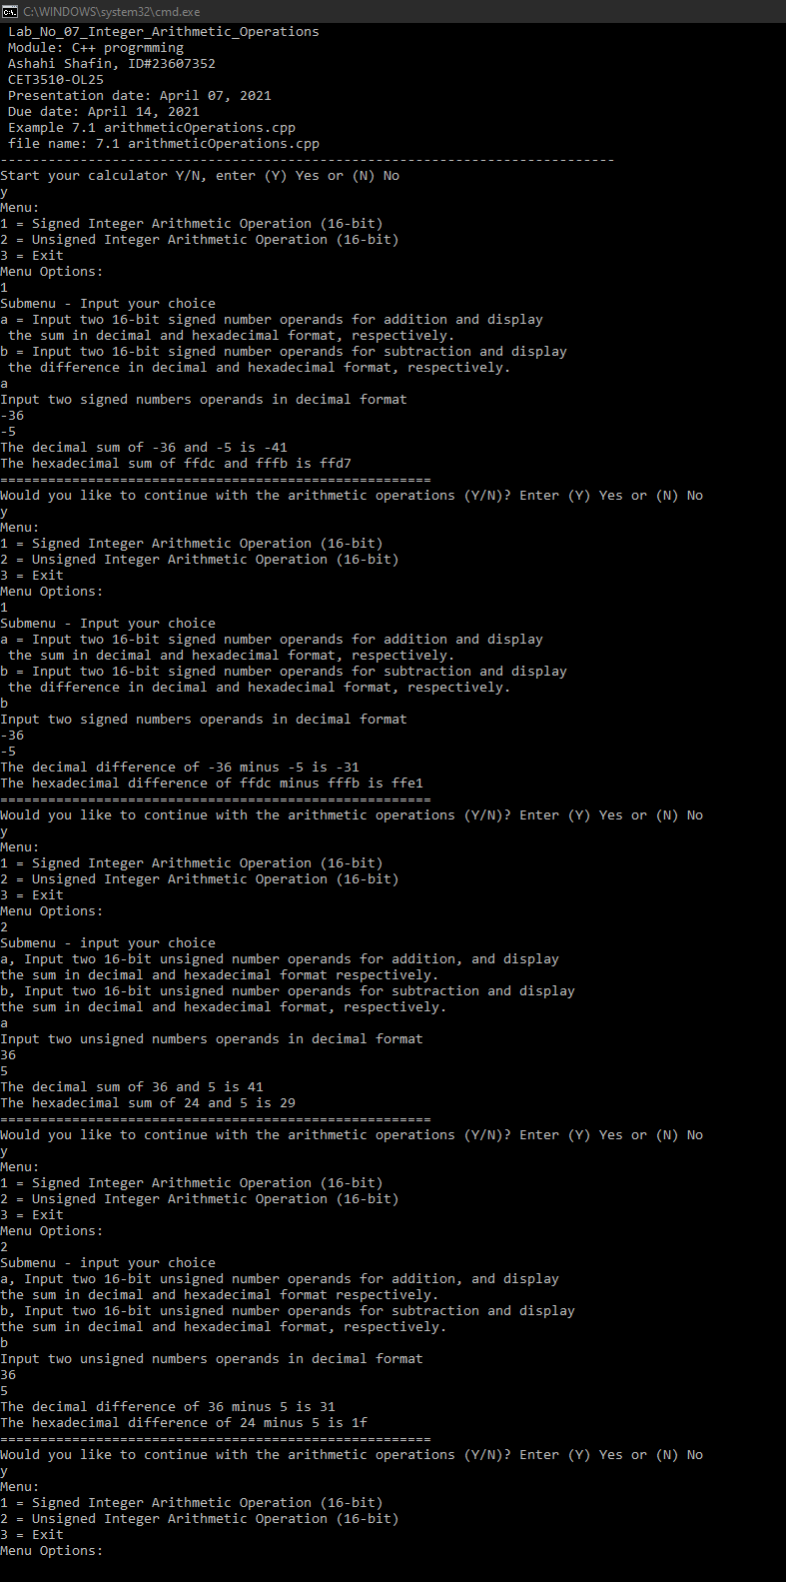

- PROGRAM FLOW CHART:

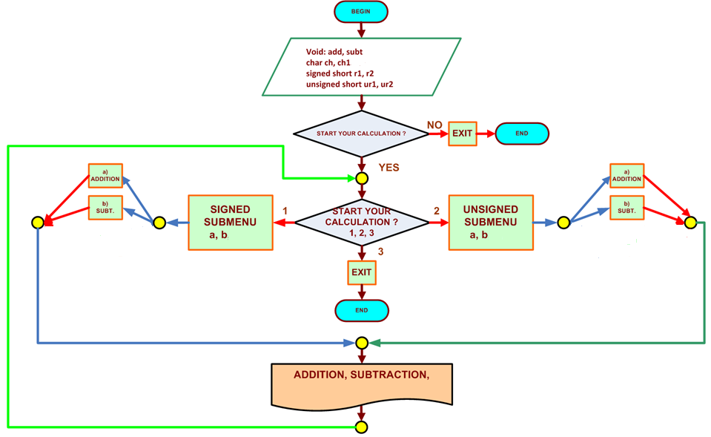

- COMMENTS

Comments on Outputs and Tables show is that when you pick the number it lets you add and sub the number depending on your choice which is useful the user if they want to pick a number.

- CONCLUSION

In this experiment, the module shows that when you use 16-bit number and signed and unsigned numbers to add them and subtract them and make it so we can pick the numbers. The hardest part of the lab was when I was making the code because I had a lot of error with cout which was a easy fix since my problem was I type count which isn’t a c++ command.

A real-life application for laboratory No 7 would be in a computer because computer they are always moving files and sharing them and when this is happen they have transfer 16 at the same time and this very useful with servers because they need to transfer files and connect with each other’s.

